Ryan Conyac and Derek Renfro

KWIC Assignment 2

1. Process Architecture

For this assignment the program was worked on used paired programming, with Ryan programming and Derek maintaining the architecture and scope of the program. The documentation was done as individual components with each person working on a part of the diagrams and components then having each other person review the others documentation.

2. Requirement Specification

In this application the user has direct interaction with two functions, the Input and Output. The input has an extended functionality for the circular shifting of the input words and sentences. The circular shifter includes some functionality to sort the sentences and filter out noise words specified on the server. This sorted and filtered text is then made available for the output function to display for the user.

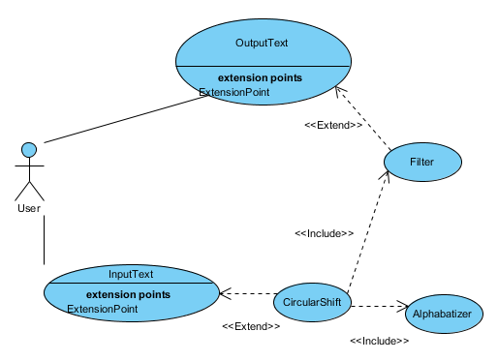

3. Architecture Specification

In this component diagram it can be seen the master control contains two components namely the input and Output components. The other component in use in the system is the KWIC, this includes three sub components. One is the circular shift where the input text is shifted to have the first word moved to the back of the sentence. The next component is the alphabetizing which sorts the shifted sentences to be in order of a<A<b<B<…<z<Z. Lastly is the filter component that removed sentences from the list of output based on a given list of noise words.

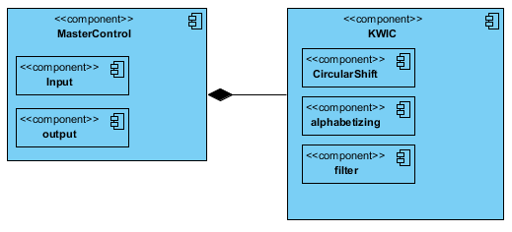

The jar file and the html file are deployed onto the webserver for clients to connect to and access the application.

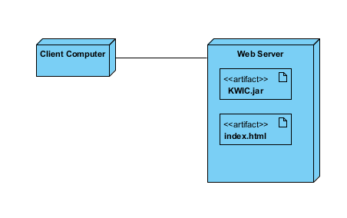

4. Design Specification

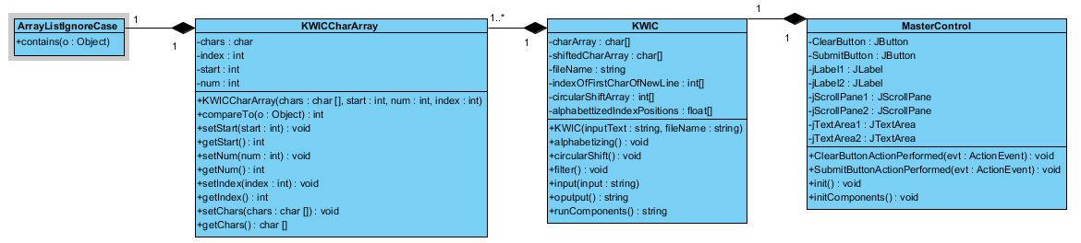

5. Implementation Specification

Once the user starts the web page from their local computer or on the deployed webserver this is the screen they will be presented with.

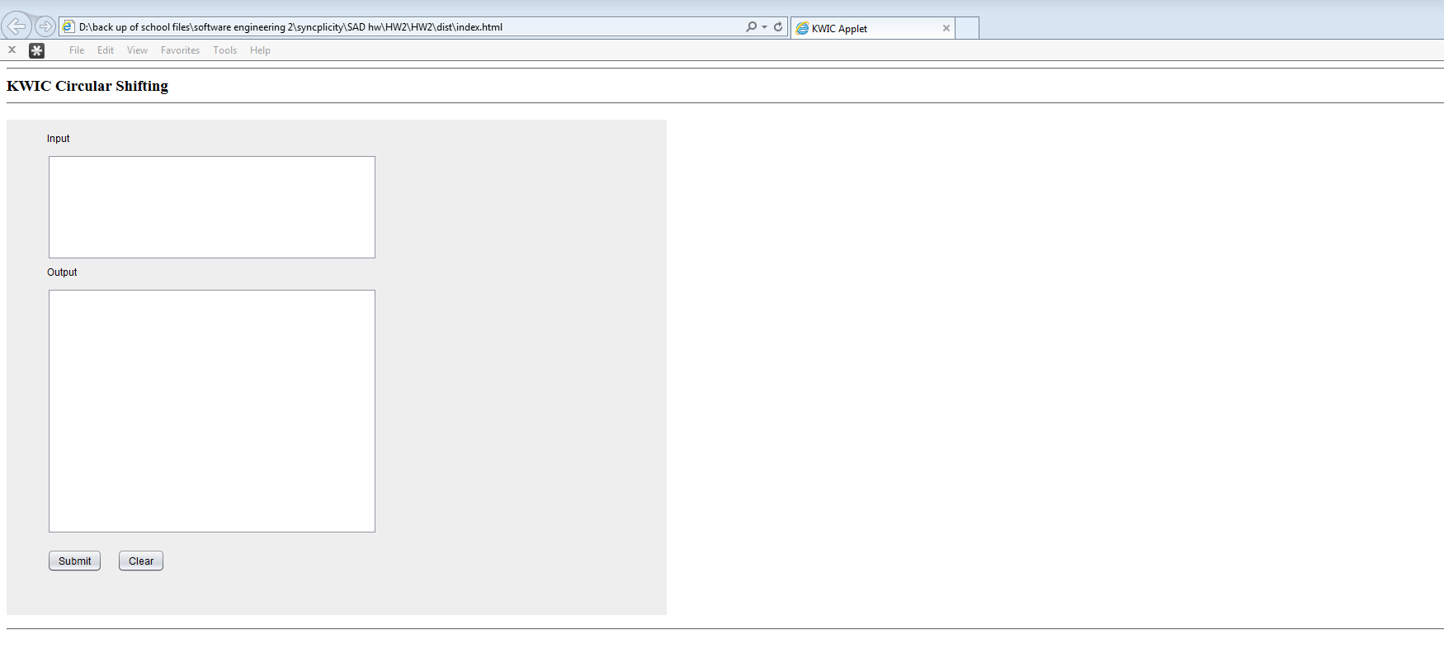

The user simply needs to enter in the input strings they would like to have ran through the shifter and click the submit button.

